**CHARTING THE COURSE OF INNOVATION: A STARTUP ANALYSIS**

**1. INTRODUCTION**

**1.1 OVERVIEW:**

A startup is a company in the early stages of development that is set up by one or several people to enter an existing market with unique products or services. The dynamics of the startup process can be vastly different depending on Institutional context and level of economic development. There are considerable differences across countries in the Orientation of entrepreneurial activities to high potential startup.

**1.2 PURPOSE:**

A startup analysis is essential to the success of any startup business. It allows entrepreneurs to identify the key areas that need improvement and make necessary changes early on. Doing a startup analysis also allows startups to track their progress and ensure that they are on track to achieve their goals. Startup India is a flagship initiative of the Government of India, intended to catalyse startup culture and build a strong and inclusive ecosystem for innovation and entrepreneurship in India.

**2. PROBLEM DEFINITION AND DESIGN THINKING**

**2.1 EMPATHY MAP:**

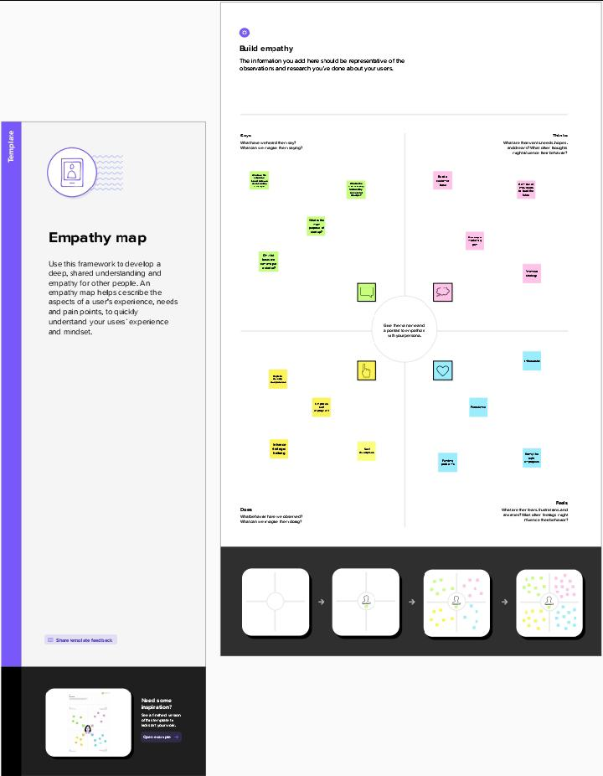

**2.2 IDEATION AND BRAINSTORMING MAP:**

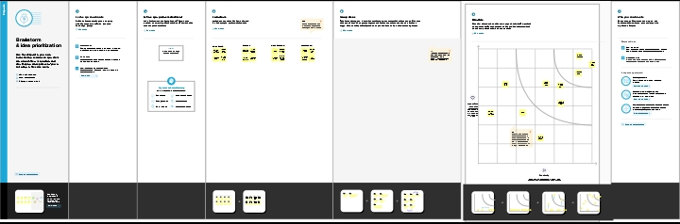

**3. RESULT**

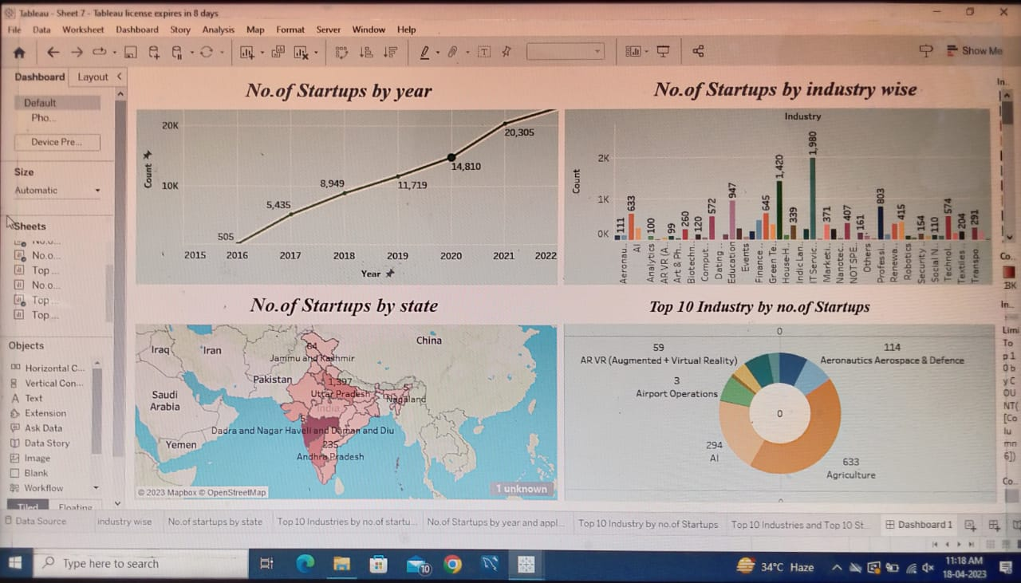

**4. ADVANTAGES & DISADVANTAGES**

**ADVANTAGES:**

* Flexible hours
* Unique experience
* Opportunities for innovations
* Increased job satisfaction

**DISADVANTAGES:**

* Heavy workload and a high level of stress.
* Fierce Competition. The corporate world is quite fierce.

**5. APPLICATIONS**

It increases the economic growth. They are the sources of new jobs, new product and new services. They drive innovation and wealth. It also enhance the industry.

**6. CONCLUSION**

While the world-changing potential in startups is sometimes overhyped, successful startups do have the potential to create a significant positive impact on the world. And even when startups fail, they still have an impact, especially through the learnings for the founders, employees, investors and other stakeholders. Other startups are looking into climate change, education, health and food – to name a few key areas – with the aim of combining impact and successful business.

**7. FUTURE SCOPE**

Startups are small companies but they play a big role in the economic process. They create more jobs which insinuates more employment, and more employment means an improved economy. Not only that, a start-up contributes to economic development by increasing innovation and inducing competition. Indian startups raised USD19. 3 billion across 1,456 deals in Venture Capital (VC) between January 2021 and October 2021, against USD27. 5 billion across 1,355 deals between January 2022 and October 2022. In addition, startups in India are expected to raise USD180 billion in 2023. Joining a startup offers numerous benefits such as the flexibility to work remotely, smaller teams, and seeing faster growth in your career. Depending on your priorities, these advantages of startup employment could help you determine the next steps in your career.